Online Flower Shopping Website

SUBMITTED BY
Name : Aiman Khalid (979015) REG # 2020-GCUF-066287


BS (Computer Science)

SESSION (2020-24)

Department of Computer Science

G.C University, Faisalabad
2024

DECLARATION

The work reported in the respective project is carried out by Aiman Khalid under the supervision of Mr.Ali Zaib khan Department of Computer Science GC University Faisalabad Pakistan.
We hereby declare that the “Online Flower Shopping Website ” and the contents of project is the product of our own research. We further declare that this work has not been submitted for award of any degree / diploma. The university may take action if the information provided is found inaccurate at any stage.

Name: Aiman Khalid
Signature: ______________ ___ Reg. No: 2020-GCUF-066287

CERTIFICATE BY THE PROJECT SUPERVISOR

This is so certifying the Aiman Khalid Roll No. 979015 has successfully completed the final project names as: “Online Flower Shopping Website” at the Department of Computer Science GC University Faisalabad to fulfill the partial requirement of the degree of BS (CS).

Internal Examiner
Name:
Signature: _____________

Incharge
Signature & Stamp:

STATEMENT OF SUBMISSION

This is so certifying the
3, Aiman Khalid Roll No. 979015 has successfully completed the final project names as: “Online flowers shopping website” , at the Department of Computer Science GC University Faisalabad, to fulfill the partial requirement of the degree of BS (CS).

Project Supervisor: __________________
Project Examiner: ___________________

Department of Computer Science, GC University Faisalabad.

Acknowledgement

Firstly, we are thankful to ALLAH ALMIGHTY who blessed us with knowledge to complete this project. We truly acknowledge the cooperation and help make by Mr. Ali Zaib Khan teacher at Salim Habib Education Complex, T.T Singh for his help and guideline throughout this project. He has been a constant source of guidance throughout the course of this project. He helped in requirement gathering and specification.

Name : Samda Marrium Name:Aiman Khalid
Date: Sep,17,2024 Date: Sep,17,2024

Executive Summary
We are stuck with technology when what we really want is just stuff that works. With the current paradigm shift in technological field, there is an urgent need to embrace and appreciate the power of technology. Discover a vibrant selection of fresh flowers, elegant arrangements, and thoughtful gifts at our online flower shop. Whether you’re celebrating a special occasion or simply want to brighten someone’s day, we offer a diverse range of bouquets, seasonal collections, and customizable options to suit any taste. Enjoy convenient delivery services, same-day options, and a commitment to quality that ensures every petal is perfect. Explore our site today to find the ideal floral expression for every moment.
Our online flower shop, where you can find the perfect floral arrangements for every occasion. Whether you're celebrating a birthday, expressing sympathy, or simply wanting to brighten someone's day, we offer a stunning selection of fresh flowers and customized bouquets. Our user-friendly website makes it easy to browse through our diverse categories, ensuring you find exactly what you need. With options for same-day delivery and beautiful add-ons like chocolates and vases, sending a heartfelt gift has never been easier. Explore our collection today and experience the joy of giving flowers with just a few clicks!
Shopping for flowers online offers numerous advantages that enhance the gifting experience. The convenience of browsing a wide selection from the comfort of your home allows you to easily compare prices, styles, and customer reviews. With options for customization and gift add-ons like chocolates and cards, you can create a personalized touch. Plus, online florists often feature seasonal collections and eco-friendly choices, catering to diverse preferences. Accessible 24/7 and equipped with flexible payment methods, online flower shopping is designed to make sending beautiful arrangements effortless and enjoyable, no matter where your loved ones are located.

After doing this project we will be able to implement above described tools and technologies in professional world. During the whole duration of project, we will learn how to work in a group. We will improve weakness of each other during the working of project. During the project working we will apply legal engineering principle. We will apply the ethics during work group.

Table of Contents
Declaration 2
Acknowledgements 5
Executive Summary 6
Table of Contents 7
Chapter 1 10
1.0 Introduction……………………………………………………………… 11
1.1 Background 11
1.2 Motivations and Challenges 12
1.3 Literature Review/Existing Solutions 13
1.4 Gap Analysis 13
1.5 Proposed Solution 13
1.6 Project Plan 13
1.7. Report Outline 16
1.7. Empathy Map 17
Chapter 2 18
2.0 Introduction 19
2.1 Purpose 19
2.2 Overall Description 21
2.3 External Interface 22
2.4 System Features 23
2.5 Nonfunctional Requirements 26
2.6. Domain Requirements 27
Chapter 3 28
3.0 Use Case Analysis 29
3.1 Use Case Description 29
3.2 Fully Dressed Use Cases 34
Chapter 4 35
4.0 System Design 36
4.1 Architecture Diagram 37
4.2 Domain Model 37
4.3 Entity Relationship Diagram with data dictionary 38
4.4 Class Diagram 38
4.5 Sequence / Collaboration Diagram 40
4.6 Activity Diagram 41
4.7 Component Diagram 42
4.8 Deployment Diagram 43
4.9 Data Flow diagram 44
Chapter 5 45
5.0 Implementation 46
5.1 Planning Training System testing Changeover Planning 46
5.2 System maintenance & evaluation 46
5.3 Important Flow Control/Pseudo codes 47
5.4 Components, Libraries, Web Services and stubs 47
5.5 Deployment Environment 48
5.6 Tools and Techniques 48
5.7 Best Practices / Coding Standards 49
5.8 Version Control 49
Chapter 6 51
6.1 Use Case Testing 52
6.2 Equivalence partitioning 55
6.3 Boundary value analysis 55
6.4 Data flow testing 55
6.5 Unit testing 56
6.6 Integration testing 56
6.7 Performance testing 56
6.8 Stress Testing 57
Chapter 7 58
7.0 Project Summary 59
7.1 Achievements and Improvements 59
7.2 Critical Review 59
7.3 Seasonal Notification 60
7.4 Future Enhancements/Recommendations 60
Appendices 61
Appendix A 61
Reference and Bibliography 64

Lists of Figures
Figure 1.1 Empathy Map……………………………………………………………..17
Figure 2.1 Product Perspective……………………………………………………….21
Figure 2.2 Communication Interface………………………………………………....23
Figure 2.3 Response Sequence ………………………………………………………25
Figure 4.1 Architecture Diagram ………………………………….…………………37
Figure 4.2 Domain Model……………………………………………………………37
Figure 4.3 ER Diagram………………………………………………………………38
Figure 4.4 Class Diagram……………………………………………………………38
Figure 4.5 Sequence Diagram ……………………………………………………….40
Figure 4.5 Collaboration Diagram …………………………………………………..40
Figure 4.6 Activity Diagram…………………………………………………….…...41
Figure 4.7 Component Diagram……………………………………………………..42
Figure 4.8 Deployment Diagram…………………………………………………….43
Figure 4.9 Data Flow Diagram………………………………………………………44
Figure 5.3 Flow Control…………………………………………………….……….47

List of Tables
Table 1.1: Role and Responsibility………………………………..…………………15
Table 1.2: Gantt chart……………………………………………..………………….16
Table 2.1: Documents Convention……………………………..……………….……19
Table 2.2 System Specification…..................................…..........................................22
Table 3.1 Use Case for Login………………………………..……………………….30
Table 3.2 Use Case for Signup ….………………………..………………………….30
Table 3.3 Use Case for Ads……………………………..……………………………31
Table 3.4 Use Case for Flower Sale……...…………..………………………………31
Table 3.5 Use Case for Flower sale…………………..………………………………32
Table 3.6 Use Case for Picture……………………….………………………………32
Table 3.7 Use Case for Views Ads..…………………………………………………33
Table 3.8 Use Case for Search Flower Products.. …………… ……………………..33
Table 3.9 Use Case for Book Mark…………………………………………………..34
Table 3.10 Use Case for Chang password……………………..……………………..34
Table 6.1Select Flower Category ….…..…………………………………………….52
Table 6.2 Home Screen…………..…..…………………………………………..…..53
Table 6.3 Working Database…….…….……………………………………………..54
Table 6.4 Admin Side TEST CASE 1 Add Customer……...………………………..54
Table 6.5 Delete Record……………………………………………………………...55
Table 6.6 Update Record………...…………………………………………………..55
Table 6.7 View Property …………………………………………...………………..56
Table 6.8 Unit testing………….....…………………………………………………..57

Chapter 1

Introduction

1.0 Introduction
We are developing a website and application with some amazing features. The website and application is full project. The main idea is that it is a Website and application named as Petals and Posies venture helps the families to buy Flowers for home and you're celebrating a birthday, expressing sympathy, or simply wanting to brighten someone's day
An online flower shopping website enhances the digital experience by providing seamless navigation and real-time inventory, allowing customers to easily browse and select available products. Personalized recommendations help users discover new options based on their preferences, while secure payment gateways ensure the safety of financial information. The mobile-friendly design enables shopping on the go, and instant chat features offer immediate customer support. Additionally, social media integration allows for easy sharing of purchases, and email notifications keep customers informed about their orders and promotions. Access to user reviews builds trust, and targeted marketing strategies engage customers with updates on new products and discounts. Overall, these digital tools create a streamlined and efficient shopping experience.
So, we will give them an online platform where seller/purchaser can interact with each other without involving third party. Seller can provide location delivery to consumers or consumer can also access the seller at their place.

Background
Online buying & selling Flowers has become a popular way of shopping for consumers. This new innovation for shopping not only brings a great number and variety of merchandise to potential consumers, but also offers a numerous business activities and huge market. Social media is no longer known only as a media that facilitates its users to present themselves on the internet but also as media to sell some products to consumers known as an online shop. Because of the numerous advantages and benefits, more people say that they prefer online shopping over conventional shopping these days. Online shopping or marketing via internet is the use of technology (computer) for better marketing production.
Online shop on Instagram now develops its function along the updated and the increase of people’s needs. Companies that sell stuffs such as clothes, makeup, shoes, have learned to use the recent technologies like Instagram in order to be able to reach the potential buyer since almost everyone uses social media these days. Over these past years E-commerce has developed very fast because of many advantages related to buying on internet because of easier transaction and lower cost as compared to other types of shopping. Through online shopping everyone can buy faster, have more alternatives and can order various product or services with lower price.

Motivations and Challenges
The motivation for designing this shopping-cart application came because I love online shopping rather than spending lot of time at physical markets. Further, using the available stores to sell the products, there is also the possibility of designing one’s own customized shopping-cart application from scratch because custom-designed platforms are expensive. Moreover, I value recent learning about the Java and JavaScript programming languages as well as seeing how powerful and dynamic they are when it comes to web designing and applications. Apart from helping computer science students understand the concepts of android-application designing, it would be very easy to incorporate the idea of using programming techniques from the available visuals to understand how a piece of code appears on a user interface
- Compatibility with browsers like play store, Internet explorer etc.
- Using a layered approach in developing the application which would make the application maintainable.
- Learning new technologies like using Xml for drag and drop behavior and java toolkit controls with little guidance.
The overall idea of doing this project is to get a real time experience. Learn new technologies.

Goals and Objectives
The system should have a login. A login box should appear when the system is invoked. The Admin should have all the type of authority. The Admin should maintain record of the new products model that is added. Admin identify that these flowers are new fresh or not. The Admin user can inform their agents for regarding to availability of new Flowers as well as update the information regarding all sorts of products and cancellation of products of home or changing user choice.
The user should book there Flowers . The system is very useful for the Flowers stores that can post and edit their availability of different models of products along with their personal info and admin can monitor records of all of them. Planned approach towards working: - The working in the organization will be well planned and organized. The data will be stored properly in data stores, which will help in retrieval of information as well as its storage.
1.2.1.1 Reliability
The reliability of the proposed system will be high due to the above stated reasons. The reason for the increased reliability of the system is that now there would be proper storage of information.

Literature Review/Existing Solutions
The rise of e-commerce has transformed the way people purchase goods and services, including flowers. Online flower shops have gained popularity, offering convenience, flexibility, and a wide range of flower arrangements. This literature review examines the current state of online flower shops, focusing on website design, customer satisfaction, and marketing strategies.
Website Design and User Experience
Studies emphasize the importance of user-friendly website design in online flower shops (Kim et al., 2019; Lee et al., 2020). Effective design elements include:
1. Simple navigation
2. High-quality product images
3. Clear product information
4. Secure payment processing
Customer Satisfaction
Research identifies trends shaping the online flower industry (Floral Marketing Research Fund, 2020; Society of American Florists, 2020):
1. Sustainable and eco-friendly practices
2. Personalized and customized arrangements
3. Increased demand for online ordering and delivery
Marketing Strategies
Online flower shops employ various marketing strategies to attract customers (Kotler et al., 2019; Singh et al., 2020):
1. Social media marketing
2. Email marketing
3. Search engine optimization (SEO)
4. Loyalty programs

Gap Analysis
- Evaluate the current features, including product range, search capabilities, and checkout process.
- Review existing channels for customer feedback, reviews, and social media presence.
- The system needs more human power.
- The user cannot get information about New kinds of flowers when they need.
- There is too match time consumption find New kinds of flowers .
- The publicity is not good and unknown by people.

Proposed Solution
The proposed system is a web application. It can be accessed by anywhere in the country. The proposed system will overcome the mediators. The proposed system builds a direct communication between the Flowers Stores and customer. With this both have an understanding and maintain their deals directly without any third party mediators. petals and posies management system in proposed system is used to search the New kinds of Flowers in particular place in market. It is user friendly web base application. petals and posies management system is used to search the available New different flowers Products in the online Market.

Project Plan
To build our Online petals and posies website with a methodology which gives us the rapid result so we can test our prototype for user testing purpose then launch a final website as soon as possible in current market. In this all process first, we research and plan properly so we’ve strong base work to stand on, after completing their search we’ll proceed towards designing and development and make sure that the current requirements meet with our project. At the end we’ll finish deploying.

Work Breakdown Structure
1.6.1.1 Requirement Gathering
- Technical specification
- Restricted areas
- Available solutions
1.6.1.2 Establish Design
- Design elements
- Banner
- Footer
- Logo
- Color scheme
- Font usage
- Icons
- Content
- Header
1.6.1.3 Admin panel:
- Admin dashboard
- Visit page List
- Verify user register page.
1.6.1.4 User panel:
- Home/index page
- Register page
- User profile page
- Houses Detail page
- Cheat Option
- Not Found Page.
- Log-in/ Sign-up Page
1.6.1.5 Database Module
- Database operations
- CRUD operations
1.6.1.6 Documentation
- User Documentation
1.6.1.7 Services
• REST web API Services
1.6.1.8 Testing
- Performance testing
- Load testing
- Security testing
- Unit testing
- Integration testing
- System testing

Roles & Responsibility Matrix
WBS | WBS  Deliverable | Activity | Activity to  Complete the  Deliverable | Duration | Responsible  Team Member(s) & Role(s)
01 | Project Proposal | 01 | Planning | 16 | Name
02 | Documentation | 02 | software requirements specification (SRS) | 8 | Name
03 | System analyzing | 03 | Market Analysis | 3 | Name
 |  |  | Surveys | 2
 |  |  | Research | 3
04 | System designing | 04 | Flow chart | 4 | Name
 |  |  | Use case diagram | 1
 |  |  | ERD | 2
 |  |  | Sequence Diagram | 3
05 | User Interface  Design | 05 | Diagrams | 7 | Name
06 | Front end Coding | 06 | HTML, CSS,  Bootstrap, AJAX | 20
07 | Back End Coding | 07 | PHP, JavaScript,  MySQL | 40
08 | Testing | 08 | Tools for testing | 7
09 | Maintenance | 09 | Search defects | 8
10 | Final  Documentation | 10 | MS word, MS  Project, MS Visio documentation
Table 1.1: Role and Responsibility

1.6.1.10 Gantt Chart
Project Schedule | March- 2024 |  | April- 2024 |  | May- 2024 |  | June-  2024 |  | Summary
Tasks: | W1 | W2 | W1 | W1 | W2 | W3 | W4 | W1 | Hours | Percent
Requirements | 10 | 10 | 5 |  |  |  |  |  | 25 | 14.90%
Design |  |  |  | 10 | 5 | 5 |  |  | 20 | 13.20%
Code & Unit  Test |  |  |  |  |  |  | 10 | 20 | 40 | 22.20%
Integrate &  Test |  |  |  |  |  |  |  |  | 50 | 21.10%
Write User’s  Manual |  |  |  |  |  |  |  |  | 15 | 6.60%
Report writing |  |  |  |  |  |  |  |  | 100 | 20.20%
Demonstrate |  |  |  |  |  |  |  |  | 7 | 1.90%
Hours | 10 | 10 | 5 | 10 | 5 | 5 | 10 | 20 | 207 | 100.00%
Table 1.2: Gantt chart

Report Outline
Documentation is the backbone of the project. In documentation, we decide the resources for our project to complete. In this documentation have covers all possible aspects of the project that are necessary to complete a project. There are:
- Introduction, Background and Scope of the Project
- Purpose, Gap Analysis and Proposed Solution of the Project
- System Features
- Functional and non-functional of the System
- Use Case Analysis: Use Case Model, fully dressed Use Case
- System Designs
- System Implementation
- System Flow
- Version Control

Empathy Map
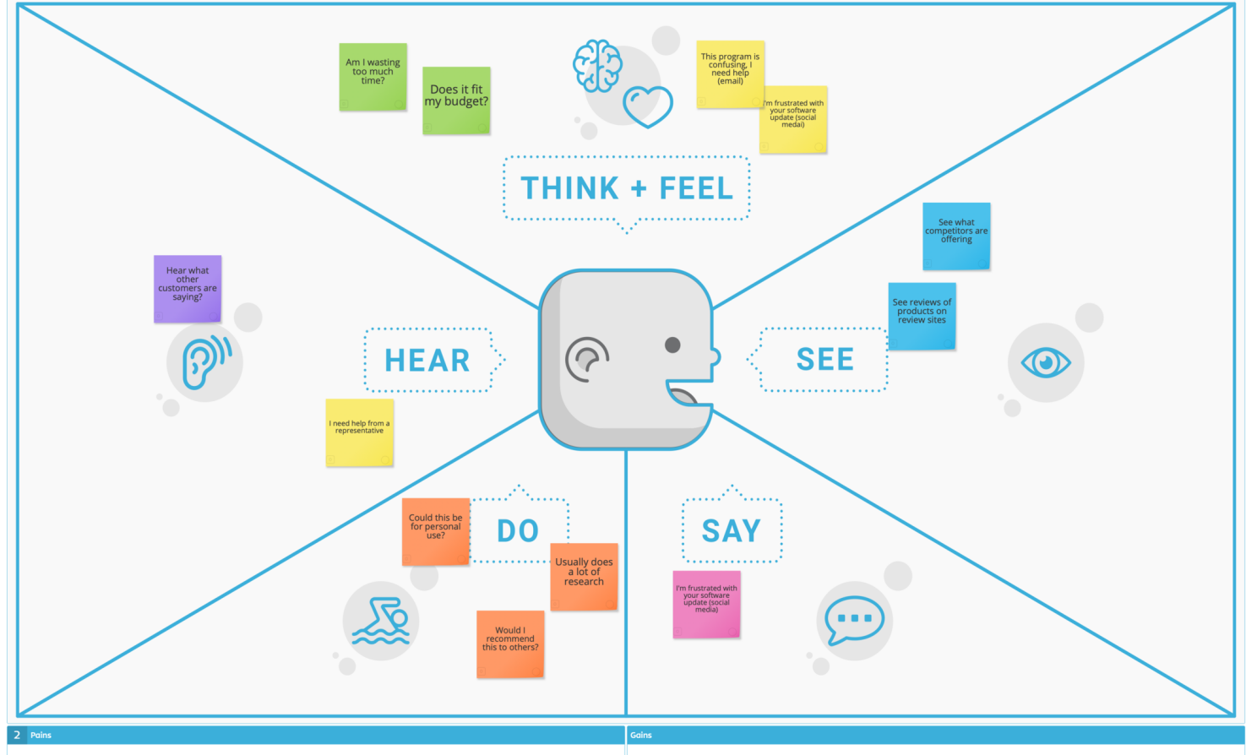
Figure 1: Empathy Map

Chapter 2

Software Requirement Specifications

2.0 Introduction

Purpose

This document is meant to delineate the features of OLRS, so as to serve as a guide to the developers on one hand and a software validation document for the prospective client on the other. The Online Flowers shopping website or Online Flowers were Products item shop web application is intended to provide complete solutions for vendors as well as customers through a single get way using the internet. It will enable vendors to setup online Home Products usage families to browse through the shop and purchase them online without having to visit the shop physically. The administration module will enable a system administrator to approve and reject requests for new shops and maintain various lists of Web category.

Document Conventions
SHORT FORM | FULL FORM
ERD | Entity relationship diagram
DB | Database
SRS | Software requirement specification
UML | Unified Modeling Language
DFD | Data flow diagram
GPA | Grade point average
WBS | Work breakdown structure
IDE | Integrated development environment
GUI | Graphical user interface
HTTP | Hypertext transfer protocol
FTP | File transfer Protocol
WAN | Wide Area network
LAN | Local area network

Table 2.1: Document Convention

2.1.2 Intended Audience and Reading Suggestions
We sell an online Flowers products website which is not only used for our business purpose but customers also take advantage from it. Check availability of new models of home products at any time. This project is not in a prototype mode. We built this website especially for increment of our business. This is being implemented under the supervision of university professors.

Product Scope
The scope of an online flower shopping website is to provide a convenient platform for customers to browse, select, and purchase a wide variety of flowers and floral arrangements from the comfort of their homes. The website should feature an intuitive user interface with well-categorized product listings, including options for bouquets, special occasion arrangements, and seasonal flowers. Additionally, it should offer detailed product descriptions, images, and customization options like selecting flower types or adding notes. Key functionalities include a secure payment gateway, delivery scheduling, and real-time order tracking. The website will also cater to diverse customer needs, such as personal gifting, corporate orders, and event decoration, while offering multiple delivery options like same-day or express services. Through seamless navigation and a reliable backend, the website aims to provide an efficient, user-friendly shopping experience, thus catering to both individual and bulk buyers.
Making this website we face the real challenges that we face and we have come over it.
- To give a platform to Flowers lover and buyers.
- Customers can find different kinds flowers for home decoration .
- Customers can search and buy any products according to price.

References
- www.slideshare.com
- www.tutorialpoint.com
- www.webdevelopernotes.com
- www.dotnetfunda.com

Overall Description

Product Perspective
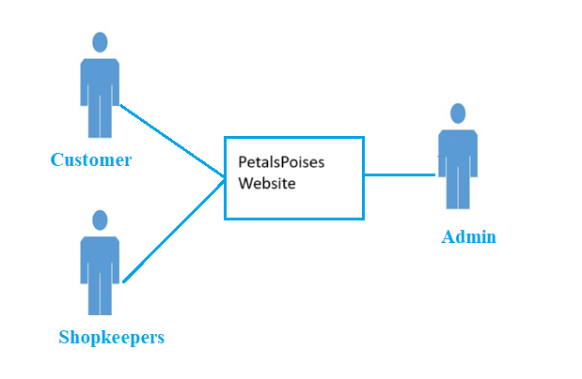
Figure 2.1 Product Perspective
Our ( Flowers shopping Website) contains the following functions
- This website uses form everywhere in the World.
- Our website is accessible to every desktop and android or any other device.
- User Friendly.
- Easy to use.

User Classes and Characteristics
The following functions are performed by this product:
- Cross platform support: Offers operating support for most of the known and commercial operating systems. Ex: windows (GUI only), Linux, UNIX, Macintosh, Android.
- User account: The system allows the user to create their accounts in the system and provide features of updating and viewing profiles.
- Number of users being supported by the system: Though the number is precisely not mentioned but the system is able to support a large number of online users at a time.
- Search: search is simply local search engine based on key words.
- This website contains the homes, flats, offices available for rent related information which can be accessed from anywhere.
- Book their favorite flowers for home .
- On every device this website is runs perfectly.
- Easy to use and attractive UI.

Operating Environment
Hardware requirements for insurance on internet will be same for both parties which are as follows
Processor | Dual Core
RAM | 4GB
Hard Disk | 320 GB
Table 2.2 System Specification

2.2.4 Design and Implementation Constraints
The software program layout (maintainability) will now not be obligation of developer or organization.
- It is going to be the responsibility of the admin.
- In case of any mishap within the software the developer or employer will now not be responsible for that lose?
- Developer or organization gives a first trail of the software program and after that they will not entertain their quires.
- After delivering the project any changes in the software will be charged by per hour

Assumptions and Dependencies
2.2.5.1 Assumptions
- It is assumed that the requirements are complete.
- It is assumed that user can use internet browser
- It is assumed that user know how to use mouse and keyboard
- It is assumed that user has an internet connection
2.2.5.2 Dependencies
- User’s stages are previously determined for all the users
- Access to the system is restricted to the user’s name
- Restrictions and boundaries of all of the degrees are known by means of the high-level users

External Interface Requirements

User Interfaces
- Web supporting NetBeans

Hardware Interfaces
- Server side Hardware
- Hardware Recommended by the all the software needed
- Communication hardware to server client request.
- Client side Hardware
- Hardware recommended by respective client operating system & Web browser.
- Communication hardware to communicate the server.

Software Interfaces
- Server side software
- SQL-Server software
- Server side scripting tools (Support Web is mandatory)
- Database tools (Sql Database is mandatory)
- Compatible operating system

Communications Interfaces
The two parties should be connected by LAN or WAN for the communication purpose.
SENDER
RECEIVER

Figure 2.2 Communication Interface

2.4 System Features
2.4.1 Application Features Admin
- Register
- Login
- Add New kinds of Flowers shopping products with prices
- View Models of flowers with prices
- Update Models of flowers products with prices
- Delete Models Of flowers Products with prices
- Log out
2.4.2 App Features Use
- Register
- Login
- View Models of flowers Products with prices.
- Select Models of flowers Products with prices.
- Customize Models of flowers Products with prices.
- Delete Models of flowers Products with prices.
- Confirm Design
- View payment details
2.4.3 System Feature
Admin must be register to the system by providing the required information. It is the high priority feature to use the system. So, admin must have to register.

2.4.3.1 Description and Priority
The Online petals and posies web application shall have three types of authentication:
- Admin authentication
- Flowers Store authentication
- Customer authentication
2.4.3.2 Stimulus/Response Sequences
2.4.3.2.1 Welcome page
After login the Welcome window show and display the options. Its priority is 9 as without it system can’t go further.
2.4.3.3 Functional Requirements
2.4.3.3.1 REQ-SF1-1: Flower Store Login
The Flowers Store can login thorough website to post new ads or upload new kinds of flowers Products with prices delete existing data. When the user login into it the data saved into the server. The following things are required for the login process:
- Email Id
- Password
2.4.3.3.2 REQ-SF1-2: Customer Login
The customer can login into the petals and posies website by using their email ID. They check new kind of flowers Products with prices. for sale. If accidentally they lost their password admin can recover it no time.

2.4.4 System Feature 2
2.4.4.1 Search
Search is the most common feature of the system. It’s the basic feature so that’s the user can find their desired result according to their need.
2.4.4.2 Description and Priority
User can easily search any type of flowers with prices at any city. User search desire categories of flowers with prices.

Stimulus/Response Sequences
The Following responses take place which are given below:
- User sends the request of desired result. System check the query of the customer whether they requesting the right request or not if it’s ok it’s give the result in a desired format which user can understand.
- Customer authentication takes place when they order their services. System checks all their details if it’s good order successful. When customer logins in the system it checks all their details if they find something wrong the login attempt becomes unsuccessful.

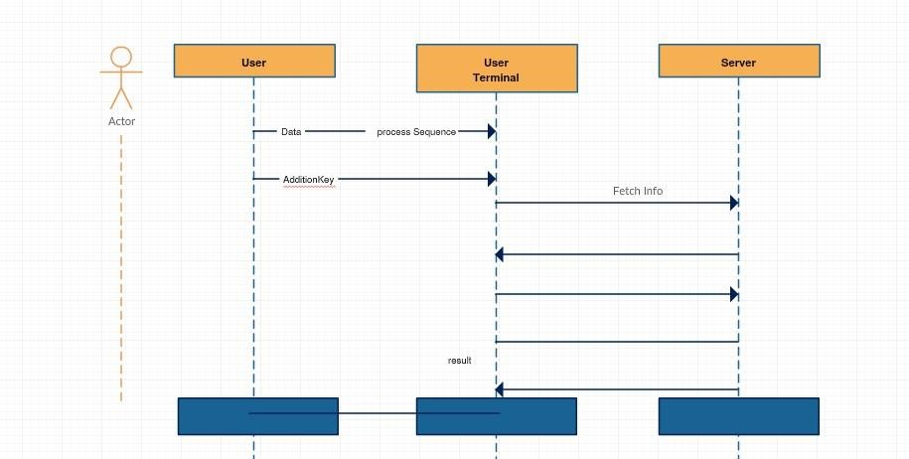
Figure 2.3 Response Sequence

Functional Requirements
2.4.4.4.1 REQ-SF1-1: Advisor Login
The Flower Store can login thorough website to post arrival of new categories of new flower Products with prices. of the season and update delete existing availability of the products. When the user login into it the data saved into the server. The following things are required for the login process:
- Email Id
- Password
2.4.4.4.2 REQ-SF1-2: Tenant Login
The customer can login into the online petals and posies website by using their email ID. They check new arrival of flowers with prices available for sale. If accidentally they lost their password admin can recover it no time.
2.4.4.4.3 REQ-SF1-3: Admin Login
Admin is monitoring the both user and customer side, admin can update, review etc.

System Feature 3

2.4.5.1 Search
Search is the most common feature of the system. It’s the basic feature so that’s the user can find their desired result according to their need

Nonfunctional Requirements

Performance Requirements
Its processing time would be efficient no stuck concerns would be suffered from user’s side. The normalization would be implemented because it will reduce redundancy that means information would be stored only once multiple times storing information can lead to wastage of storage space and increased
The size of the data stored. If database is not properly designed means improper relational database can cause a problem to avoid this we can normalize the database. The hardware that we using at the back up like server, workstations etc. should be risk free and works properly. At the peak time performance should not be decrease. Better component design for better Performance.

Safety Requirements
If there would be a comprehensive damage to a wide-ranging portion of the database due to the improper entries by the user. We would have the recovery method that it is a past and the most recent copy of the database that would lead to safe our synchronized data. Uses the fire wall because the traffic should be filtered not unauthorized traffic affect the system and performance. Anti-viruses, USB detectors etc. are used for safety purposes.

Security Requirements
To secure the whole system is the essential requirement that must be implemented specifically in the database storage just the way many other applications.

Usability Requirements
The website should satisfy the customer needs.

Reliability Requirements
Data validation & verification need to be done at every stage of activity. Validation user input

Maintainability/Supportability Requirements
The admin should maintain the records of the customers. The website would be easily available in any time at any place.

Portability Requirements
The application is developed in NetBeans. It would be portable to other operating system provided. As the database is made in SQL Server, porting the database to another firebase server would require some development effort.

Efficiency Requirements
Efficiency requirements address the user concern for how fast the system functions and how efficiently the system takes in inputs and processes outputs and how much can be processed at a time.

Domain Requirements
Domain requirements are the requirements which are characteristic of a particular category or domain of projects. The basic functions that a system of a specific domain must necessarily exhibit come under this category.
Domain-specific requirements include consideration of flower availability and seasonality, bouquet and arrangement customization, delivery options (same-day, next-day, scheduled), gift wrapping and card options, and detailed product information (description, images, care instructions).

Chapter 3

Use Case Analysis

3.0 Use Case Analysis
In this chapter we discuss all about use case. Use case analysis is a technique used to identify the requirements of a system and the information used to both define processes used and classes which will be used both in the use case diagram and the overall use case in the development or redesign of a software system or program.

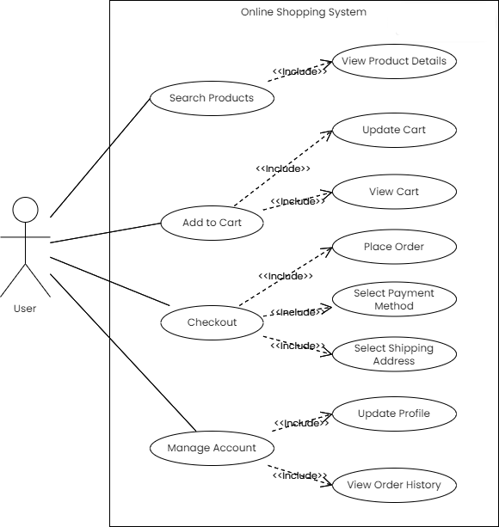

3.2 Use Cases Description
Number | OLM1
USE CASE Name | Login
Summary | System user can login
Priority | 5
Preconditions | User Account must be created
Post-conditions | It will display the dashboard.
Primary Actor(s) | Flower Store, Customer
Secondary actor | Database
Frequency of occurrence | At the start of the user visiting the website
Special requirements | Internet connection, supportive web browser
Stakeholders | Admin, User(Advisor, Tenant)
Trigger | Click on login button
Main scenario | The user will enter his/her correct username and password. The system will allow the validated users to access system.

Table 3.1 Use Case for Login
Number | OLM2
USE CASE Name | Sign up
Summary | User must sign up before using the main features of the website. Like posting the Ads and search for the Products.
Priority | 5
Preconditions | User must have internet and supportive web browser and user must have email account
Post-conditions | User signed up successfully
Primary Actor(s) | Flower Store , Customer
Secondary actor | Database Online Flower Products Management
Frequency of occurrence | At the start of the user visiting the website
Special requirements | Internet connection, supportive web browser
Stakeholders | Admin, User(Advisor, Tenant)
Trigger | Create
Main scenario | New user account will create account for all actors as per the permissions. It will take mandatory information from the user and create user account to use further.

Table 3.2 Use Case for Signup

Number | OLM3
USE CASE Name | Ads
Summary | The Store Owner Can Post Products Model Ads
Priority | 5
Preconditions | User should have account and logged in as well
Post-conditions | Ads Posted
Primary Actor(s) | Furniture Store
Secondary actor | Database
Frequency of occurrence | After logged in
Special requirements | Internet connection, supportive web browser
Stakeholders | Flower Store Owner
Trigger | Click on Ads button
Main scenario | The user access system At home.

Table 3.3 Use Case for Ads
Number | OLM4
USE CASE Name | Flowers Buying
Summary | The Store Can Post Products Model Ads
Priority | 5
Preconditions | Store Owner has flowers to sale
Post-conditions | Categories of flowers posted
Primary Actor(s) | Store Owner
Secondary actor | Database
Frequency of occurrence | At the start of the user visiting the website
Special requirements | Internet connection, supportive web browser
Stakeholders | Admin, User(Advisor, Tenant)
Trigger | Click on login button
Main scenario | The user will enter his/her correct username and password. The system will allow the validated users to access system.

Table 3.4 Use Case for petals and posies Sale

Number | OLM5
USE CASE Name | Furniture Products for Sale
Summary | The Store Can Post Products Model Ads
Priority | 5
Preconditions | User Account must be created
Post-conditions | Flower Products posted
Primary Actor(s) | Store Owner
Secondary actor | Database
Frequency of occurrence | After logged in
Special requirements | Internet connection, supportive web browser
Stakeholders | Store Owner
Trigger | Click on login button
Main scenario | The user will enter his/her correct username and password. The system will allow the validated users to access system.

Table 3.5 Use Case for flower Products sale
Number | OLM6
USE CASE Name | Picture
Summary | Shopkeeper have rights to add picture for Furniture Products
Priority | Medium
Preconditions | There’s no pre-condition.
Post-conditions | User can view full detail of Ads without login.
Primary Actor(s) | Store owner
Secondary actor | Database
Frequency of occurrence | At the start of the user visiting the website
Special requirements | Internet connection, supportive web browser
Stakeholders | Store owner
Trigger | Click on Picture button
Main scenario | The user will enter his/her correct username and password. The system will allow the validated users to access system.

Table 3.6 Use Case for Picture

Number | OLM7
USE CASE Name | View Ads
Summary | Here user can do searches and view different type of Ads
Priority | High
Preconditions | There’s no pre-condition.
Post-conditions | User can view full detail of Ads without login.
Primary Actor(s) | Customer
Secondary actor | Database
Frequency of occurrence | At the start of the user visiting the website
Special requirements | Internet connection, supportive web browser
Stakeholders | Admin, User(Advisor, Tenant)
Trigger | Click on login button
Main scenario | The user will enter his/her correct username and password. The system will allow the validated users to access system.

Table 3.7 Use Case for View Ads
Number | OLM8
USE CASE Name | Search categories of flowers
Summary | Any user can search and browse FlowerssAppliance Ads
Priority | Medium
Preconditions | Anyone can do this. No initial pre condition
Post-conditions | They will get the Desired Flowers
Primary Actor(s) | Flower Store, Customer
Secondary actor | Database
Frequency of occurrence | When anyone visit the site
Special requirements | Internet connection, supportive web browser
Stakeholders | Site visitor
Trigger | Click on login button
Main scenario | The user will enter his/her correct username and password. The system will allow the validated users to access system.

Table 3.8 Use Case for Search For flowers Products

Number | OLM9
USE CASE Name | Book mark
Summary | The Customer can booked any Flower if like
Priority | 5
Preconditions | Store can have categories of flowers
Post-conditions | It will display the dashboard.
Primary Actor(s) | Customer
Secondary actor | Database Flower Products management
Frequency of occurrence | Store Owner of shops adds more categories of flowers they will do input details in their profile.
Special requirements | Internet connection, supportive web browser
Stakeholders | Admin, User(Advisor, Tenant)
Trigger | Click on Bookmark button
Main scenario | The user will enter his/her correct username and password. The system will allow the validated users to access system.

Table 3.9 Use Case for Book Mark
Number | OLM10
USE CASE Name | Change password
Summary | System user can change password if anybody know
Priority | 5
Preconditions | User Account must be created old password
Post-conditions | It will display the dashboard.
Primary Actor(s) | flower Store, Customer
Secondary actor | Database
Frequency of occurrence | At the start of the user Click on change password
Special requirements | Internet connection, supportive web browser
Stakeholders | Flowers Store, Customer
Trigger | Click on login change password button
Main scenario | The user will enter his/her correct username and password. The system will allow the validated users to change password.

Table 3.10 Use Case for Chang password

Number | OLM11
USE CASE Name | Sign out
Summary | System user can Sign out if anybody know
Priority | 5
Preconditions | User Account must be created login
Post-conditions | It will display the dashboard.
Primary Actor(s) | Flower Store, Customer
Secondary actor | Database
Frequency of occurrence | At the start of the user Click on change password
Special requirements | Internet connection, supportive web browser
Stakeholders | Flower Store, Customer
Trigger | Click on Sign out button
Main scenario | The user will enter his/her correct username and password. The system will allow the validated users to change password.

Table 3.11 Use Case for Sign Out

Chapter 4

System Design

4. System Design
- The system needs a minimum of 2 GB of ram to run all the features smoothly and suddenly.
- It needs a minimum of 1.3 GHz processor to run smoothly as less than that may create problems.
- The system needs to be operated by some authorized person as wrong hands can make it irresponsible.
- Rest is all up to the user’s usage will care for hardware.
- For security Antivirus is recommended.
- The system is made properly and all the testing is done as per the requirements. So, the rest of the things depend on the user and no one can harm the data or the software if the proper care is done. All the attributes are working perfectly and if any error is found then it can be removed easily.

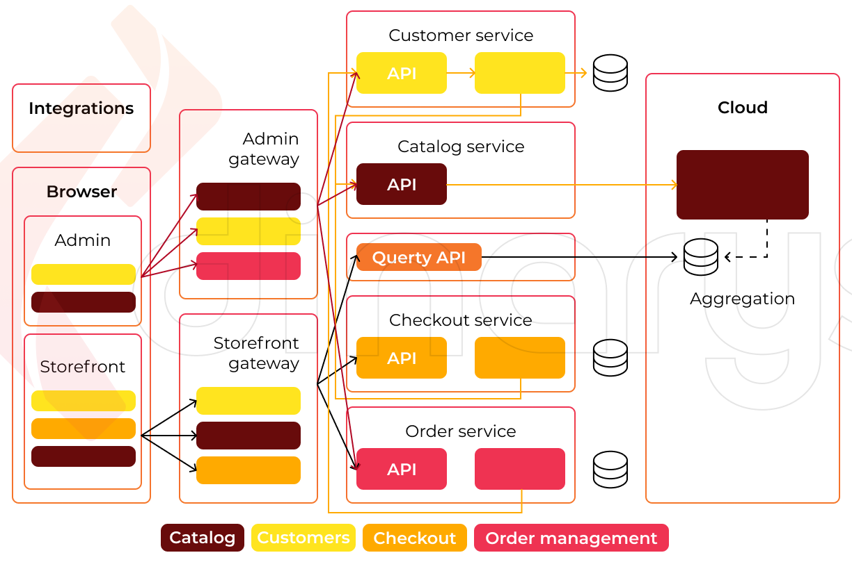
Architecture Diagram

Figure 4.1 Architecture Diagram

Domain Model
A space express describes important abstract classes in an issue area. It is the most essential antiquity to make amid protest-situated study. A space display is generally utilized as a wellspring of motivation for planning programming objects.

Find Your Desired
petal and posies

Customer
Sold
petal and posies
petal and posies

Figure 4.2 Domain Model

Entity Relationship Diagram with data dictionary
Property ID

Date of purchase
Property Type
Area
Price
User Id
User name
Shop ID
petal and posies
Customer
petal and posies store
Buy
Password

Email
Role
Category
Description
petal and posies ID
Images
Rate
petal and posies
petal and posies ID

petal and posiesModels

Price

Figure 4.3 ER Diagram

Class Diagram
[Paragraph Text 12 pt, Calibri, 1.5 Line Spacing, Justified]

Customer
id
:
int
email
:
sting
passward
:
string
name
:
string
address
:
string
ntn nmbr
:
int
property brnad
:
string
phn
_
nmbr
:
string
post add
()
update
()
delet
()
eidt
()
Store Owner
id
:
int
email
:
string
passward
:
string
name
:
string
address
:
string
upgrade post
()
delet
()
manage user
()
confirm
()
Online flower shop webite
id
:
int
email
:
string
passward
:
string
name
:
string
address
:
stirng
phn
_
nmbr
:
string
view post
()
search post
()
select post
()
Register
id
:
int
email
:
string
passwrd
:
string
name
:
sting
submit
()
Login
id
:
int
email
:
string
passward
:
string
check email
()
verify passward
()
Intrest id
Intrest account
_
nmbr
:
int
transcation
_
id
:
string
post
()
Online flower shop webite details
id
:
int
area
:
string
Garden
:
string
petals
:
string
Florists
:
string
advisor
_
name
:
string
home
_
discription
:
string
image
_
required
()
post
()
Province
name
:
stirng
select
_
state
()
post ads online flower shop website

id
:
int
name
:
string
price
:
string
address
:
string
save
()
remove
()

Figure 4.4 Class Diagram

Sequence / Collaboration Diagram

Sequence Diagram for Signup/Login
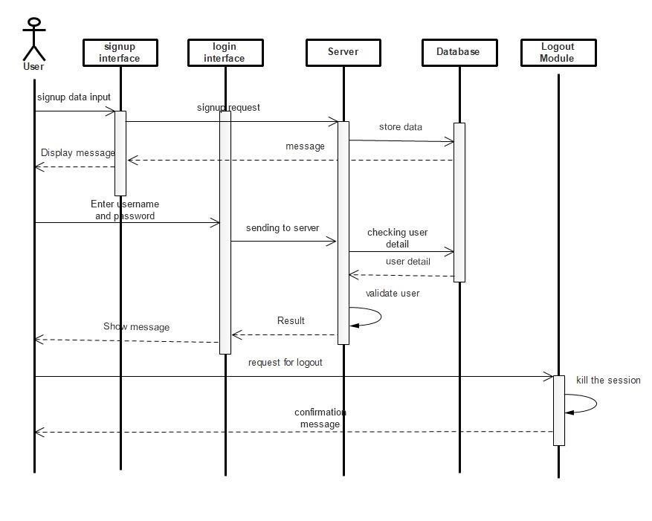
Figure 4.5 Sequence Diagram

4.6 Activity Diagram
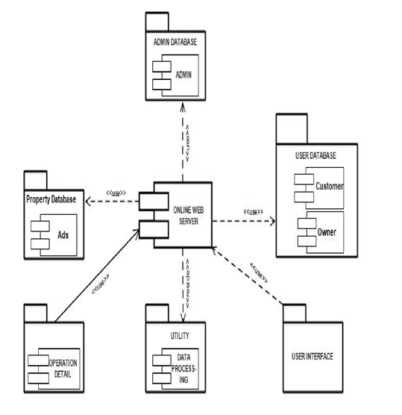
4.6.1 Activity Diagram for Admin:

Figure 4.6 Activity Diagram

4.7 Component Diagram
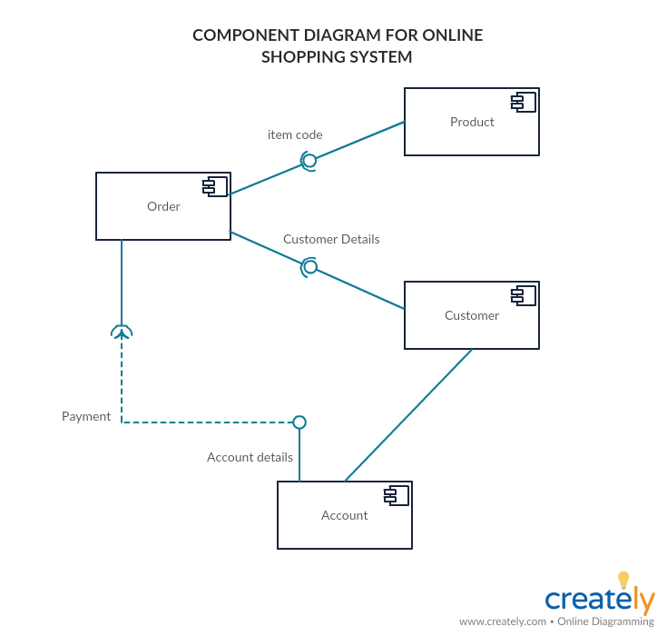
Online Flowers shopping website

Figure 4.7 Component Diagram

4.8 Deployment Diagram
[Paragraph Text 12 pt, Calibri, 1.5 Line Spacing, Justified]
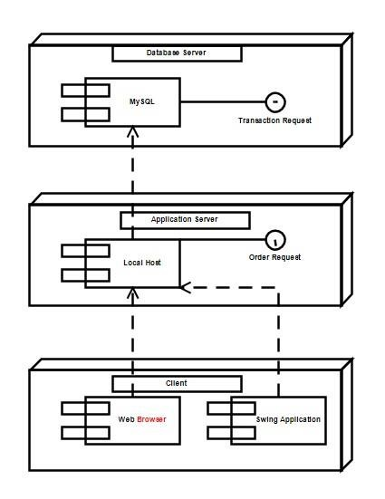
Figure 4.8 Deployment Diagram

4.9 Data Flow diagram
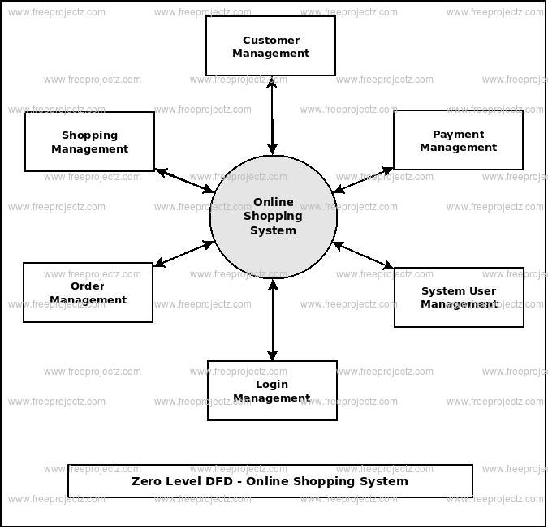

Store Owner
Property

Figure 4.9 Data Flow Diagram

Chapter 5

Implementation

5. Implementation
Purpose System implementation is the important stage of project when the theoretical design is tuned into practical system. The main stages in the implementation are as follows:
5.1 Planning Training System testing Changeover Planning
Planning is the first task in the system implementation. At the time of implementation of any system people from different departments and system analysis involve. They are confirmed to practical problem of controlling various activities of people outside their own data processing departments. The line managers controlled through an implementation coordinating committee. The committee considers ideas, problems and complaints of user department, it must also consider:
- The implication of system environment
- Self-selection and allocation for implementation tasks
- Consultation with unions and resources available
5.2 SYSTEM MAINTENANCE & EVALUATION
Software maintenance is far more than finding mistakes. Provision must be made for environment changes which may affect either the computer or other parts of the computer based systems. Such activity is normally called maintenance. It includes both the improvement of the system functions and the corrections of faults which arise during the operation of a new system. It may involve the continuing involvement of a large proportion of computer department recourses. The main task may be to adapt existing systems in a changing environment. Back up for the entire database files are taken and stored in storage devices like flash drives, pen drives and disks so that it is possible to restore the system at the earliest. If there is a breakdown or collapse then the system gives provision to restore database files. Storing data in a separate secondary device leads to an effective and efficient maintains of the system. The nominated person has sufficient knowledge of the organization’s computer passed based system to be able to judge the relevance of each proposed change.

5.3 Important Flow Control/Pseudo codes

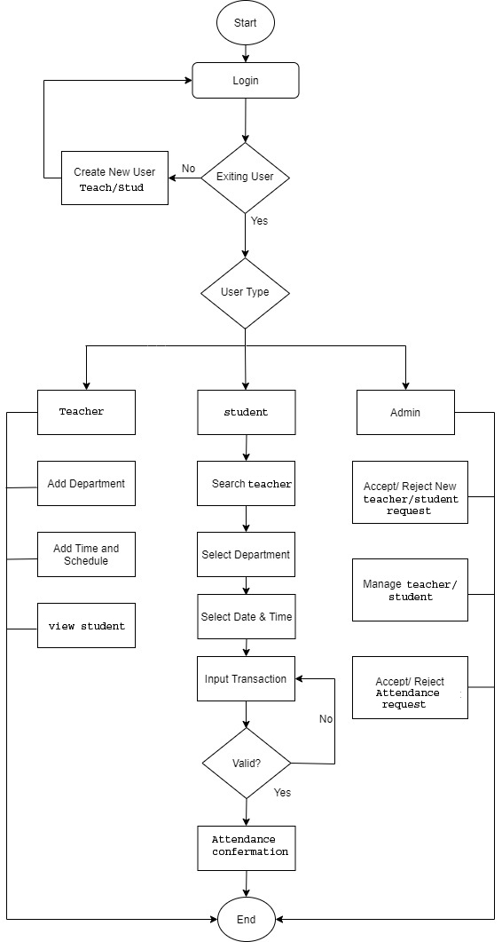
Figure 5.1 Flow Control

5.4 Components, Libraries, Web Services and stubs
Online petal and posies Store is web-based application with structured web pages and components that are integrated with each other’s.
5.4.1 Components
- Store Owner Components
- Customer Components
5.4.2 Libraries
In this project we have included bootstrap which included JS libraries for frontend of web pages that provide responsive and great UI experience. All webpages are responsive and structured. 5.4.3 Web Services Using latest tools and technology we provide great user experience via webpages.
- 24/7 availability of the system
- Book Flowers anytime
- Customer can view their cart
- Access from anywhere which will save time
- Ability to see prices
- Contact for details of Appliance Models

Deployment Environment
This system is mainly accessed by Store Owner, admins and Customer via web services and deployment environment is totally depending on services which are integrated with each other’s. All the system files and database stored in web hosting which provides high up time and fast processing. Domain name will be bind with web hosting with DNS server’s address. Domain will be accessible from the web browsers i.e., Google Chrome, Firefox or MS Edge. All users can access the system via domain with different webpages.

Tools and Techniques
Online petal and posies Store system uses the following tools and techniques.
5.6.1 Visual Code
Visual Code is used mostly HTML and CSS
5.6.2Adobe Dream Viewer
Adobe dream viewer is used to code html and handling bootstrap.
5.6.3XAMPP
XAMPP is software which run Apache services on local host, it is used host the project until it goes live.
5.6.4GoDaddy Advance Web Hosting
GoDaddy advance web hosting is used to host data of the projects such as website content, CSS and html and database
5.6.5 MYSQL
MYSQL is used to store all information in database
5.6.7Adobe Photoshop
Adobe Photoshop is used to edit and design some photos
5.6.8Adobe illustrator
Adobe illustrator is used to create images from scratch that will be used in project
5.6.9Microsoft Excel
To draw the tables
5.6.10Microsoft Word
To write the documentation of the project
5.6.11Microsoft Power Point
To prepare presentation
5.6.12Microsoft Visio
To make diagrams and charts
5.6.13Wonerdshare E-Draw Max
To make diagrams and charts
5.6.14Draw.io
To make diagrams and charts

5.7Best Practices / Coding Standards
- PSR-12 which is PHP standard coding
- Readable and concise coding
- Reusability of Code by creating JavaScript and html files.

5.8 Version Control
Version | Date | Author | Rationale
0.1 |  | Name | Html pages created
0.2 |  | Name | Database ER Diagram
0.3 |  |  | Started Reports
0.4 |  |  | Admin Panel integration
0.5 |  |  | Database Integration
0.6 |  |  | Index page with bootstrap
0.7 |  |  | Store Owner Panel Integration
0.8 |  |  | Login JavaScript
0.9 |  |  | Converted html to JavaScript
1.0 |  |  | Structured all webpages
1.1 |  |  | Connected all module and made system ready to test
1.2 |  |  | Error Testing and fixing
2.0 |  |  | System Live

Figure 5.1 Version Control

Chapter 6

Testing and Evaluation

6.1Use Case Testing

6.1.1TEST CASE 1
6.1.1.1Select Furniture Products Category
Test suite ID | S01
Test Case ID | C01
Actor | Customer
Test Case Summery | To verify Select But category button is functioning correctly.
Prerequisites | Use must be login.
Test Procedure | Login in
Test Data | Correct petal and posies . Incorrect
Expected Result | User can select petal and posies
Actual Result | petals and posies check.
Status | Test property successful.
Table 6.1Select petal and posies Category
6.1.2 TEST CASE 2
6.1.2.1Home Screen
Test suite ID | S02
Test Case ID | C02
Actor | Customer
Test Case Summery | To verify view Home screen is functioning correctly.
Related Requirement | User must be successfully Login In
Prerequisites | User must be login. Select the petal and posies category.
Test Procedure | User must login and select petal and posies
Test Data | Customer can view petal and posies
Expected Result | Customer can view petal and posies booking after attempt the login page.
Actual Result | View petal and posies after attempt the log in
Status | Test Successful.

Table 6.2 Home Screen

6.1.3 TEST CASE 3
6.1.3.1 Working database
Test suite ID | S03
Test Case ID | C03
Actor | Working database
Test Case Summery | To verify database is functioning correctly.
Related Requirement | User must be successfully Login In
Prerequisites | User must be login. Select green grocer category
Test Procedure | User must login
Test Data | Participant.
Expected Result | Participant can Selection after by the flat
Actual Result | After buying
Status | Test Successful.

Table 6.3 Working Database
6.1.4 Use case description
6.1.4.1 Admin Side TEST CASE 1 Add Customer
Test suite ID | S04
Test Case ID | C04
Actor | Admin
Test Case Summery | To verify customer buy flowers products is functioning correctly.
Prerequisites | None
Test Procedure | Admin can add petal and posies categories.
Test Data | None
Expected Result | Admin can add new petal and posies
Actual Result | petal and posies l is added
Status | Test Successful.

Table 6.4 Admin Side TEST CASE 1 Add Customer

6.1.5 TEST CASE 2
6.1.5.1 Delete
Test suite ID | S05
Test Case ID | C05
Actor | Admin
Test Case Summery | To verify Delete user after buying is functioning correctly.
Prerequisites | None
Test Procedure | Admin can off season petal and posies category.
Test Data | None
Expected Result | Admin can off season petal and posies l category.
Actual Result | can off season petal and posies category is Deleted
Status | Test Successful.

Table 6.5 Delete Record
6.1.6 TEST CASE 3
6.1.6.1 Update
Test suite ID | S06
Test Case ID | C06
Actor | Admin
Test Case Summery | To verify update button is functioning correctly.
Prerequisites | None
Test Procedure | Admin can update
Test Data | None
Expected Result | Admin can update
Actual Result | Seller is updated
Status | Test Successful.

Table 6.6 Update Record

6.1.7 TEST CASE 4
6.1.7.1 View Property
Use Case | View scores
Test suit ID | S07
Test Case ID | C07
Actor | Admin
Preconditions | Admin can view Information of petal and posies
Basic flow | Admin can view the petal and posies Information
Alternate flows | Admin can view petal and posies
Post conditions | View petal and posies detail successfully.
Status | Test Successful.

Table 6.7 View Property
6.2 Equivalence partitioning
Using the Equivalence Partitioning method test cases can be divided into three sets of input data is classes. Each test case is representative of a respective class. We can divide our test cases into three equivalence classes of some valid and invalid inputs.

6.3. Boundary value analysis
- A detailed petal and posies description.
- Customer reviews of the petal and posies
- Withdraw the payment methods.

6.4 Data flow testing
Data flow testing is utilized to analyze the stream of information within the program. It is the method of collecting information about how the factors flow the data within the program. It tries to get specific data of each specific point within the process Dataflow testing centers to focus on which factors get values and the points at which these values are used. In which we characterize numerous flow of our application additionally depict how the data is flowing in our system.
6.4.1 Admin data flow Admin login into the application then he perfumes the further Activity after Login he can view the notification of all orders, insert Admin login into the application then he perfumes the further Activity after Login he can view the notification of all orders, insert category and petal and posies upload category.
6.4.2 Participant data flow
The customer also login into the Web-based application. He can view petal and posies . He can also choose category of the green grocer.
Test Case | Step Details | Test Data | Expected Result | Actual Result
View quiz property | - Open Web-based application Then View the Quiz On the App. | View | property Quiz should be shown successfully | Property Quiz are shown successfully
Attempt property | - Open Web -based application  - Select the category.  - Reattempt the quiz. | Category mode | All the subjects categories  should be shown | quiz categories shown successfully
Dream property | - Open the android application  - Play the spin wheel game. | Participant can play the game. | Participant should be entertained with help of spinner game | Participant plays the game spin wheel successfully.
FlatP | - Participant can withdraw the winning amount | With  draw request | Participant should be withdraws his winning amount | Participant withdraw request successfully

6.5 Unit testing
Table 6.8 Unit testing

6.6 Integration testing
Integration testing (sometimes called integration and testing, abbreviated I&T) is the phase in software testing in which individual software modules are combined and tested as a group. Integration testing is conducted to evaluate the compliance of a system or component with specified functional requirements.

6.7 Performance testing
Performance testing is the method of deciding the speed, responsiveness and soundness of a Portable Application, organize, computer program or gadget beneath a
workload. Performance testing can involve quantitative tests wiped out a lab.
The performance of the software is determined by three factors:
- Speed
- Scalability
- Stability

6.8. Stress Testing
Stress testing is defined as the type of software testing that verifies the stability and reliability of the system. This test chiefly decides the framework on its vigor and blunder taking care of under incredibly hefty burden conditions

Chapter 7

Summary, Conclusion and Future Enhancements

7.0 Project Summary
Online petal and posies store Management System is a Web Based application with multiple categories and Spain wheel functionality. A good way to find out what is happening within is to look at the earning portion in which Customer can search the flowers for Home by categories and season based. In this system user can register and get logged onto the app through google account. They can select petal and posies by categories which they want to buy. Customer can add the more flowers Products into the cart and pay later on and get the product at given address. Development of web based petal and posies is mainly required by people for them is difficult to visit the shops to by multiple types of Flowers . Also get Flowers at a distance from them. One of the major goals of our project is to facilitate every type of family which feel difficult due to travelling or availability of time as well as feel difficulty in buying Flowers for Home decorations from the market.

7.1 Achievements and Improvements
As web based application is rapidly getting famous day by day and the number of its users is increasing with every blink of eye, because it is easy to access the necessary web based applications on smart phones and tablets in your hands. Therefore, we found this idea interesting, easy and time efficient to facilitate the users in this way without any difficulty. There are many online Flowers Hub Store applications available on internet but most of them are only for limited stocks.
Moreover, if one is going to buy the fresh flowers they like but it is not available at one shop then it is difficult and time consuming for them to visit multiple Furniture stores. But the most attractive feature of our web based application is that we take daily basis availability of the Flowers according to the season. Our web based application provides them the facility to get in touch when new flowers will come to the market.
The basic objective or improvement of this project is to develop a web based system with following features, namely: (i) Home (ii) Shop Details (iii) Shop (iv) Cart .The main objective to buy the fresh flowers they like but it is not available at one shop then it is difficult and time consuming for them to visit multiple shops.

7.2 Critical Review
It is essentially required to assist customer for buying daily usage fresh flowers from multiple shops by sitting in home. Also if they will not find on any Model of the Products in on shop but they can get from other shops without travelling to multiple shops. Also if someone has not experience of purchasing daily routine petals and posies they will buy easily as multiple shops are available along with prices variations. Also Flowers store owner is aware that if they will not provide the product that is showing and customer will complain that will ban them on the platform. However, there exists no such application in web-based platform, which can provide customer with all sorts of Models of different home products at one place as well as the notification if new Flowers of the season will arrive or sale on buying in different categories. This is what we tried to address in the development of Petals and posies Although there are number of web-based and android based applications which are on way or other related to Flowers product however, there are only few those helping the customer in multiple ways.

7.3 Seasonal Notification
This software is handling complex tasks of petals and posies Store. It does require a powerful server machine with high band internet access. Another performance requirement is a storage space.
Software should be developed as lightweight application so that it can work on almost at any platform even with slower machine or internet connection.

7.4 Future Enhancements/Recommendations
It is essentially required to assist customer for the searching and using different Home Flower Products of the season without visiting physically multiple shops.
However, there exists no such application in which customer will get different benefits in case they order as a regular register customer.

Appendices

Appendix A
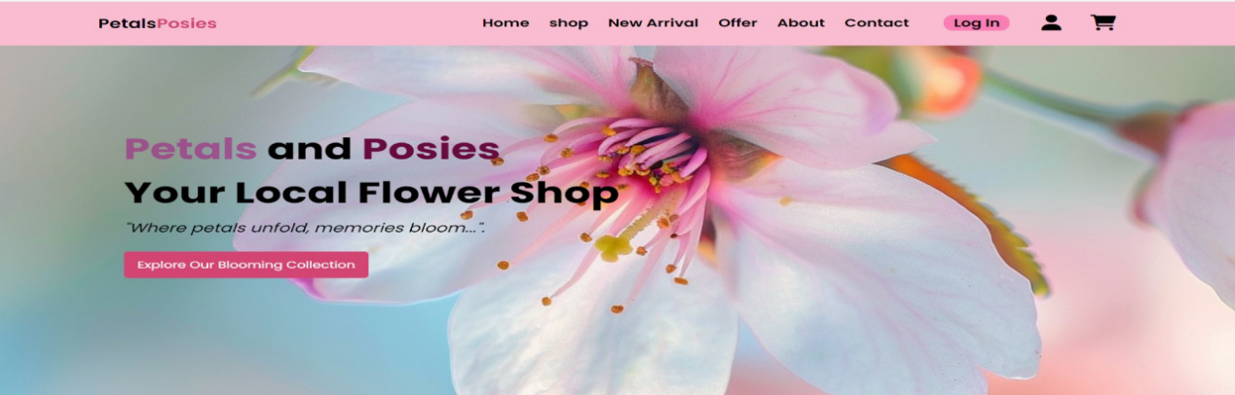
Home Screen

Appendix A: User Manual
The petals and posies will give access to the user of different flower Products that are available in the market. It will show the shops and details of the shops that which sort of product is available on the shops. It has also facility of searching the products according to the range of price that they will afford.
The main feature that is designed for the user is that if they will not get the New categories of flowers that is the main theme of the website. They have separate button for the customer complaint to which customer care will be available 24/7 that will assist them in case they will not get the required Flowers .
There price will also be returned along with the supply of same Flowers in fresh form free. These are the features that will maintain the quality of the website promises that will make them more reliable and valuable as compare to the other websites that are already working in the market.

Appendix B
How to Search Shops
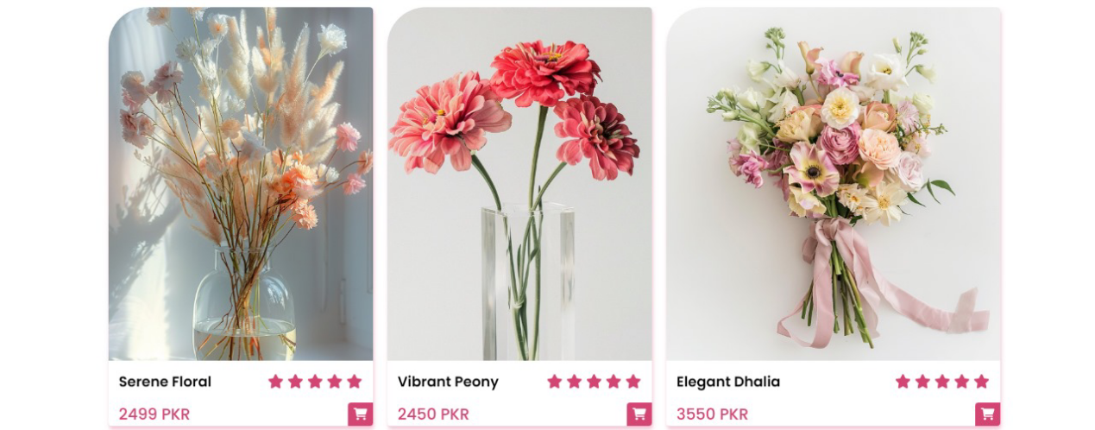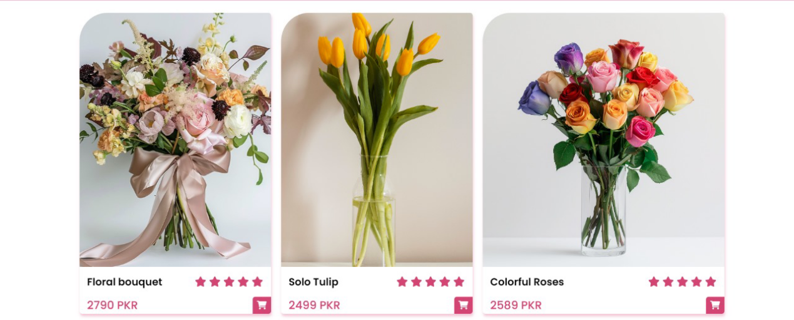

How it Work
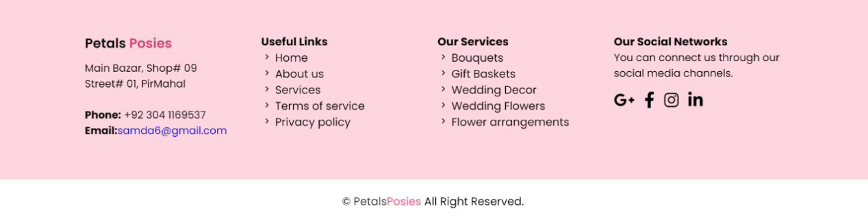
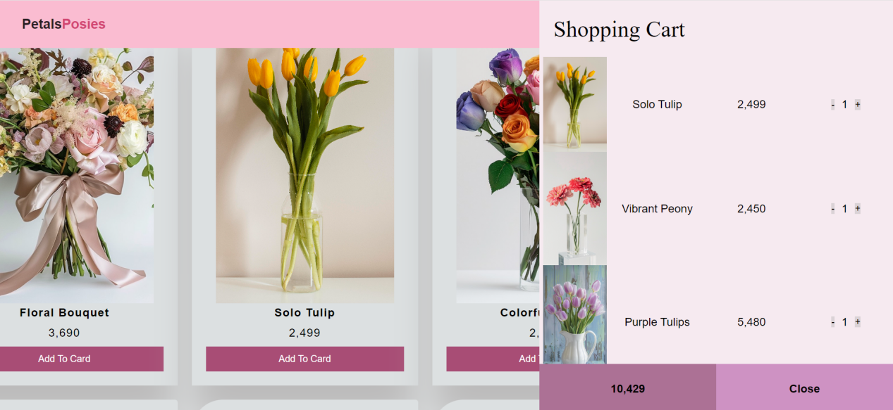

Reference and Bibliography

Reference and Bibliography
- M. Sher, M. Rehman, “Title of the Paper” Conference name/Journal Name, Edition, Volume, Issue, ISBN/ISSN, PP, Publisher/City-Country, Yea

- Chen, Y., et al. (2019). E-commerce platform selection for small businesses. Journal of Electronic Commerce Research, 19(2), 155-172.

- Floral Marketing Research Fund. (2020). 2020 Floral Industry Trends Report.

- Kim, J., et al. (2019). The impact of website design on customer satisfaction in online shopping. Journal of Retailing and Consumer Services, 49, 137-145.

- Kotler, P., et al. (2019). Marketing management. Pearson Education.

- Lee, S., et al. (2020). Effects of website quality on customer loyalty in online flower shops. Journal of Business Research, 112, 241-248.

- Patel, R., et al. (2020). Payment gateway selection for e-commerce businesses. International Journal of Electronic Commerce, 24(1), 33-50.

- Singh, R., et al. (2020). Social media marketing strategies for small businesses. Journal of Marketing and Management, 35(1), 1-15.

- Society of American Florists. (2020). 2020 State of the Floral Industry Report.

- Wang, Y., et al. (2018). Customer satisfaction in online shopping: A systematic review. Journal of Retailing and Consumer Services, 43, 137-145.

- Zhang, Y., et al. (2020). Factors influencing customer satisfaction in online flower shops. Journal of Electronic Commerce Research, 20(1), 1-12.

- Zhang et al. (2020) - "Factors Influencing Customer Satisfaction in Online Flower Shops"

